**Yin/Yang Tangle project**

**This project can be done with any materials you have around the house. I have examples with watercolors and pencil but use whatever you have, crayons, markers pens etc. The idea is to vary the value range (some areas dark, some medium, and some light)**

1. **You will need to draw a large circle that fills most of your paper; this can be done in pencil. (If you don’t have a compass, trace around a plate or any circular object you can find)**

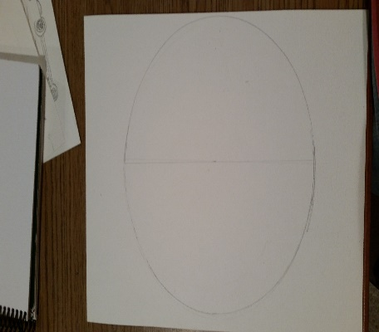

1. **Using pencil lightly divide the circle in half. This will help you add the curving Yin and Yang lines. Erase any extra lines after you have drawn out your Yin/ Yang shape.**
2. **Add a smaller circle to one side of your Yin/Yang design (I traced around the bottom of a cup)**

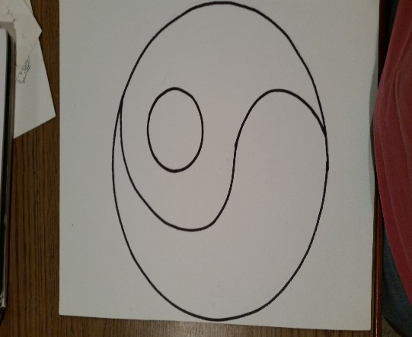

1. **On one side you will fill in with 4-6 zentangle designs on the other side you will leave it blank.**

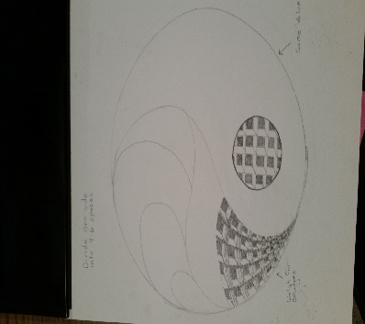

1. **On one side only fill in the small circle with a zentangle design or fill it in with a solid color if you have your designs on this side.**

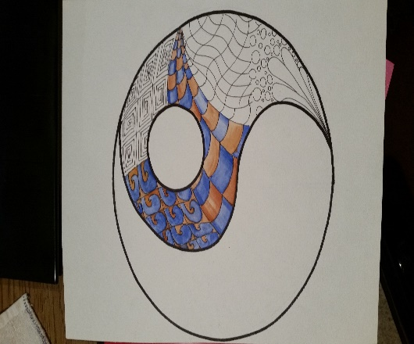

**.**

**\*Remember these are zentagle patterns and they should repeat in a predictable manner!**